Q1: List the loan id of loans with EMI more than Rs.50,000.

Ans: select loanid from loan where emi>50000;

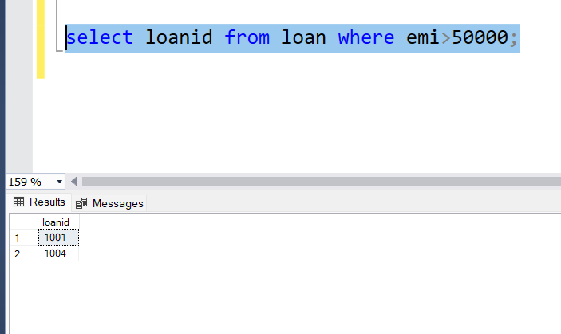

Q2:List the EMI and number of loans with that loan amount

Ans: select emi,count(emi)as NumofSameAmount

from loan

group by emi

order by emi;

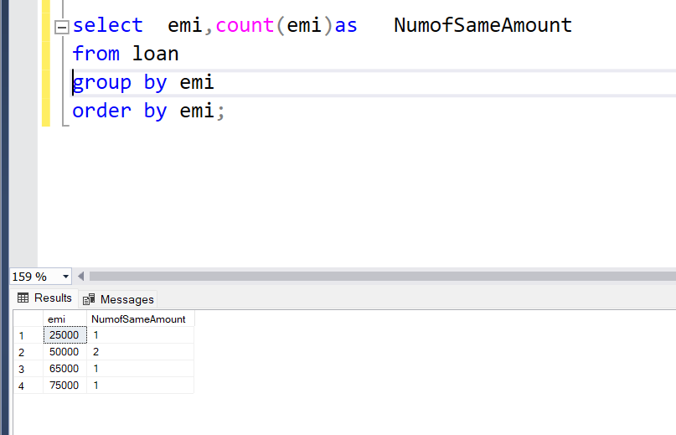

Q3:create a view to list the total number of loans availed

Ans: create or alter view totloans as (select count(*) TotalNoOfLoansAvail from loan);

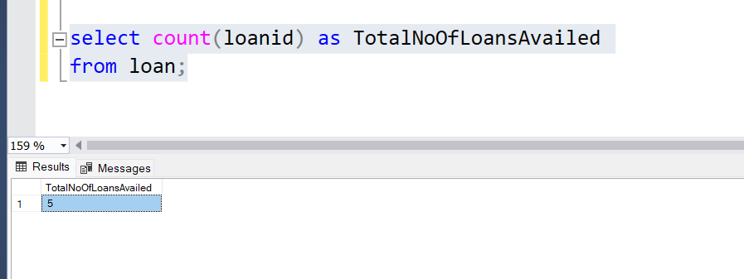

Q4: Display the emi amount of customer “SMITH”

Ans: select c.custname CustomerName, l.emi EMIAMOUNT

from customer c join loan l

on c.Custid=l.custid

where custname='smith';

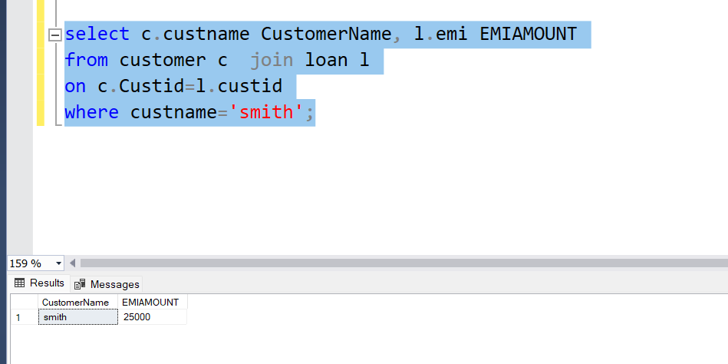

Q5:create a procedure to print the amount and custid of loanid 1001

Ans: CREATE PROCEDURE usp_loandisplay

AS

BEGIN

SELECT l.amount ,c.custid customerId from customer c full outer join loan l

on c.custid=l.custid

where loanid=1001;

END

GO

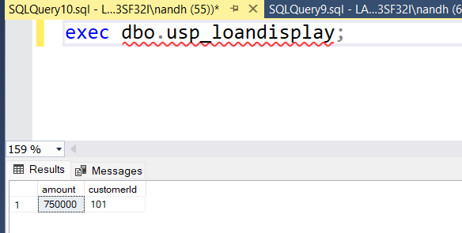

Q6:Create a function to display the loan amount of customer with custid 100

Ans: CREATE or alter FUNCTION udf_display

(

)

RETURNS TABLE

AS

RETURN

(

SELECT amount as LoanAmount ,custid as CustomerId

from loan

where custid=100

)

GO

